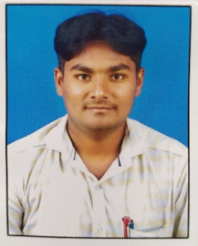
Staff Profile
Dr. Chaitanya Shankar Kamble

Designation |  | Asst. Professor in Political Science
E-mail ID |  | chaitanyakamble1991@gmail.com
Education |  | M.A., B.Lib., Ph. D.
Teaching Experience |  | 07 Years
Research Work

International Level - Published Articles |  | UGC Listed Journal -01
National Level - Published Articles |  | UGC Listed Journal -02,  Peer reviewed journal - 02, Other -02
Research Paper Presented |  | International -1, National – 7.
Faculty Development Program |  | 07
Participation in Conference/ Seminar/ Workshops/Webinar |  | 20
Academic Committees - College level

Sr. No. | Name of Committee |  | Designation
1 | Lead College Committee |  | Co-Ordinator
2 | Trip Committee |  | Co-Ordinator
3 | Gymkhana Committee |  | Member
4 | Cultural Committee |  | Member
5 | Parents & Teachers Committee |  | Member
6 | NSS Committee |  | Member
7 | Library Committee |  | Member
8 | Alumni Co-Ordinating Committee |  | Member
9 | Internal Quality Assurance Cell |  | Member
10 | Career & Employment Guidance Committee |  | Member
11 | Internal Grievance Redressed Committee |  | Member

